**DAILY ONLINE ACTIVITIES SUMMARY**

|  |  |  |  |  |  |  |  |  |
| --- | --- | --- | --- | --- | --- | --- | --- | --- |
| **Date:** | **1-6-2020** | | | | | **Name:** | **poojashree** | |
| **Sem & Sec** | **8th sem A sec** | | | | | **USN:** | **4al16cs065** | |
| **Online Test Summary** | | | | | | | | |
| **Subject** | | **sms** | | | | | | |
| **Max. Marks** | | **60** | | **Score** | | | **60** | |
| **Certification Course Summary** | | | | | | | | |
| **Course** | **Artificial intelligence** | | | | | | | |
| **Certificate Provider** | | | **GUVI** | | **Duration** | | | **3.5hr** |
| **Coding Challenges** | | | | | | | | |
| **Problem Statement:**  **1**.  **remove friends** | | | | | | | | |
| **Status:completed** | | | | | | | | |
| **Uploaded the report in Github** | | | | | **yes** | | | |
| **If yes Repository name** | | | | | **Poojashree** | | | |
| **Uploaded the report in slack** | | | | | **yes** | | | |

**Online test**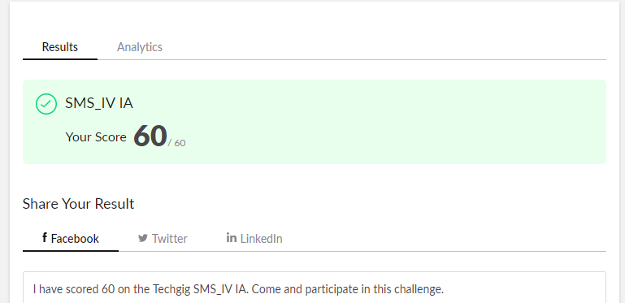

**Certification course**

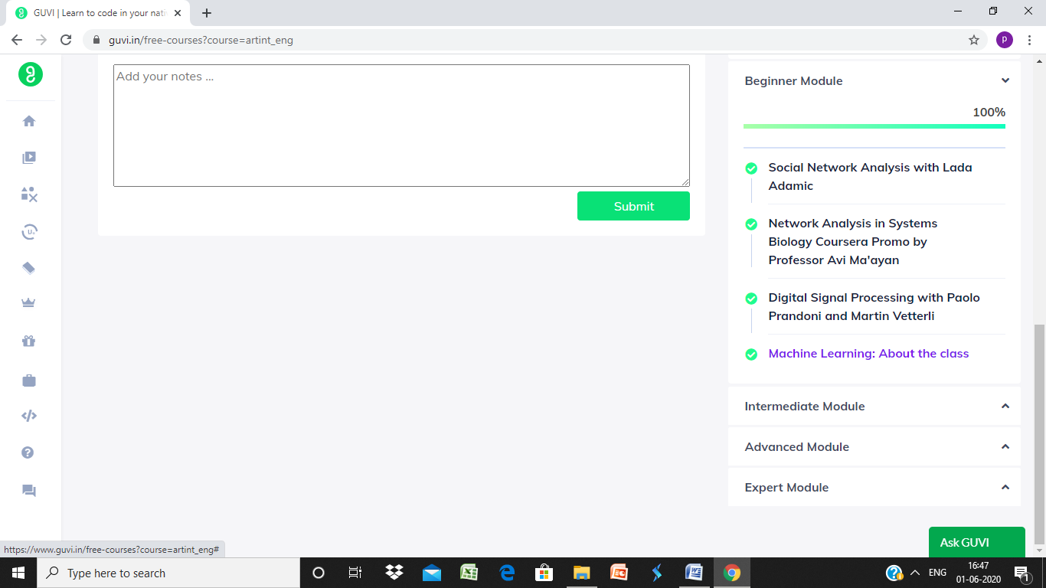

**Coding**

1. *#include* <stdio.h>
2. *#include*<stdlib.h>
3. int *stack,top;
4. int main(void)
5. {
6. int t,n,k,i,num;
7. scanf("%d",&t);
8. while(t>=1)
9. {
10. top=-1;
11. scanf("%d%d",&n,&k);
12. stack=(int*)calloc(n,sizeof(int));
13. scanf("%d",&num);
14. top++;
15. stack[top]=num;
16. for(i=1;i<n;i++)
17. {
18. scanf("%d",&num);
19. while(k>=1&&num>stack[top]&&top!=-1)
20. {
21. top--;
22. k--;
23. }
24. top++;
25. stack[top]=num;
26. }
27. while(k>=1)
28. {
29. top--;
30. k--;
31. }
32. for(i=0;i<=top;i++)
33. printf("%d ",stack[i]);
34. printf("\n");
35. t--;
36. free(stack);
37. }
38. }